

**SharePoint: Create Subsite with Template , and Use Metadata navigation**

Assignment 3

INFO 3250

Mar 25, 2018

LiWen Tan

**Task 1, Use metadata navigation**

Screenshot 1: All documents in the contract library are displayed with 2 values (confidential and public) for the Sensitivity hierarchy field

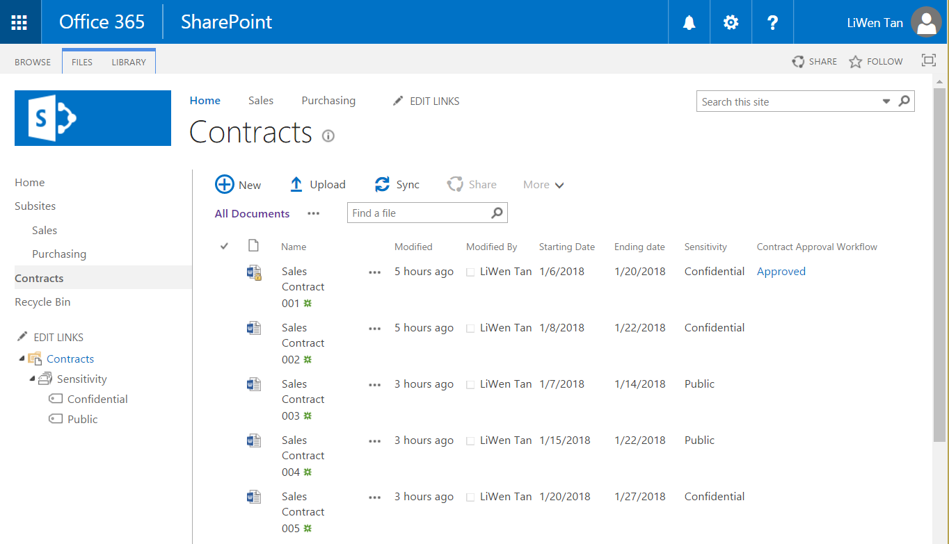

Screenshot 2: Only “public” documents are displayed, if the public value of the Sensitivity is clicked.

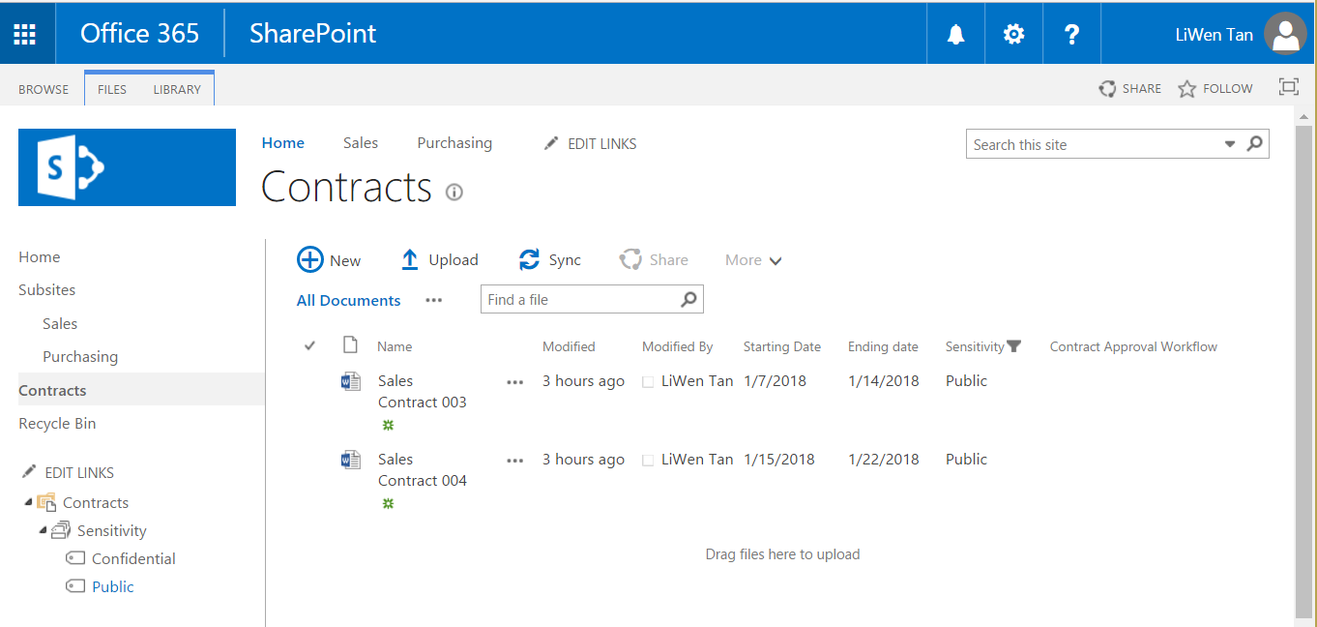

Screenshot 3: Only documents with starting date on or before a particular date (i.e., January 15, 2018 in this example) are displayed, when such a date is set using the Key Filters, regardless of their sensitivity.

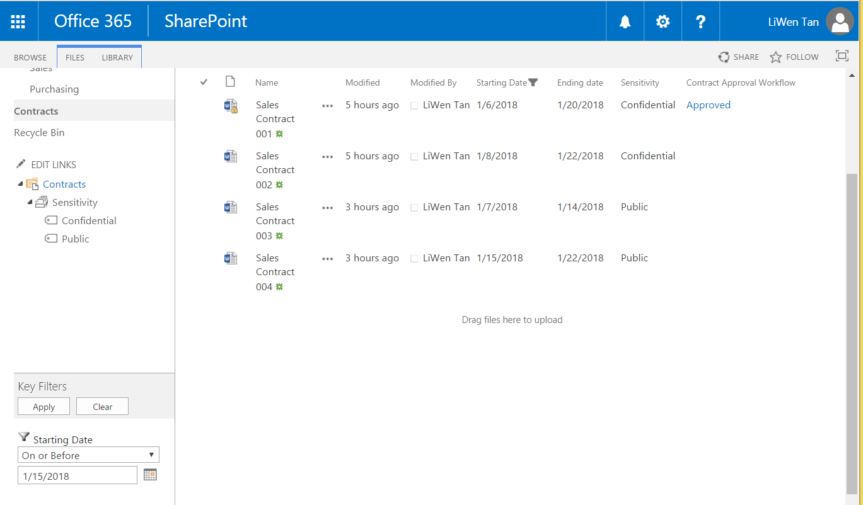

**Task 2, Create a subsite using template**

Screenshot 1: The new subsite Purchasing is created using a custom site template (i.e., Department Site Template in this example)

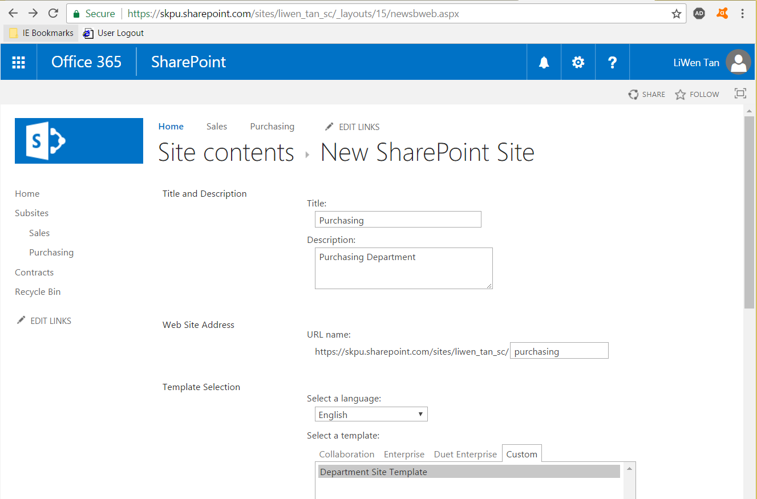

Screenshot 2: The Purchasing subsite is created. The quick launch menu items shown, and the correct message is displayed on the page.

